EGR 302 – Engineering Design and Documentation

Deliverable 1: Problem Definition and Needs Identification

Team Name: RPMs

Team Members: Dylan Shanahan

Jordan Ziegler

Tim Decious

Josh Hemsley

Brian Ungermann

Austin Hulen

Client’s Name: Dr. Xu

Version: 4

Date: 4/10/14

* 1. **Initial Problem Statement**

The project’s purpose is to build a rotating LED wand that can be used to signal for help or advertise for a company at low cost to the consumer. The client needs a display that can show words or pictures in color in a stable manner on the surface the wand creates. It can also be used to signal cars on a freeway. The display should be large enough so that the content can be easily discernable from 50m. It should also operate on a battery that can run for 1 hour on full charge, and remain charged for several months while not operating. The product must be light enough to be easily transported and it should fit in a car trunk. This can be helped by allowing the user to disassemble the product and reassemble without much effort. To exceed expectations, the display output can be controlled wirelessly by a smartphone or tablet to change the words or pictures in real-time.

* 1. **Client Interview**

The client was interviewed to get a better understanding of what he meant in the problem statement and to eliminate some questions we had about certain portions of it. The questions we asked, and the answers he gave are shown in the table (Table 1) below. After taking down his answers we interpreted them in a format that more directly relates to our project and to more clearly direct us. Those changes are also shown in Table 1.

|  |  |  |
| --- | --- | --- |
| Question | Answer | Interpretation of Needs |
| How durable should the product be? | We don't need to make it military scale. Just focus on southern california (temperatures from 30-120 degrees. | The product doesn't need to be Ironclad, but it should be able to sit outside for a while |
| Should it be magnetic on the bottom? | Yes, or use a heavy battery or something that will keep it from trembling when on top of a car. | It doesn't matter how it stays still, just that it does. |
| How long should the battery last? | One full battery should last 1 full hour running or around 4 months while not in use | Battery should last an hour in run mode, 3-4 months while off. |
| Is weight an issue we should focus on? | It needs to be easily portable in the trunk. So overall, we determine the final weight but it shouldn't be too heavy. The base should be relatively heavier so it won't shake or wobble. | It should be light enough to be portable. |
| Should it have a pretty easy assembly? | Yes, easily assembly is a priority. It needs to be easy to take apart and put together. | The Product needs to be able to be assembled and disassembled with ease. |
| Does it need to have safety features? | We need to look into this ourselves. | Yes, but it's the team's job to come up with them. |
| Should we put a set timer in the product? | Yes it would be nice to have and is pretty easy to do. | There should be a timer on the device. |
| When displaying the words on the LED do you want it to be seen from one position or multiple positions? | In the end, it's up to use. We also need to consider how big the words should be.Typical scenario should be a car breaks down on the side of the road and they get out our device and put it on top of their car asking for help. | Size and viewability is up for discussion by the team |
| How far away should you be able to see the words from? | We need to research this ourselves. (he mentioned something about 50 meters.) | Words should be visible from the side of the road so that people can see the user needs help. |

Table 1.

* 1. **Background Research and Relevant technology**

1. Existing products and technology - Research by Dylan Shanahan
   * This research identifies existing technologies or products that can be comparable and implemented into this project. It also provided ideas on how to proceed along with our own project. From this research we saw what sort of problems we might see and also what possible solutions we might utilize. The primary resource researched gave a complete report on the creation of their project. This resource demonstrates not only how to do the project but an idea of how to write the report as well.
2. Sensor and motor research and control methodologies - Research by Brian Ungermann
   * This research examines current sensors, motors, and controls for the E-Wand. The sensors will be used to determine the RPM of the cantilever and make sure its within set guidelines (LED output controls and safety features). The motor controls the turning of the arm. This research was specifically related to infrared sensors and their implementation in the project. The motor control research told what sorts of motors to use and also what type of control system needs to be implemented.
3. Microcontrollers - Research by Josh Hemsley
   * This research examines the microcontroller and relevant sensors. The microcontroller will be used as the brain of the E-Wand to control the LED’s at the end of the arm. The microcontroller will read the information from the sensors detailed in the sensor and motor research. The microcontrollers will also control the motor and keep the spin in check. The research also went into which type of microcontrollers to use and the benefits to each type.
4. Mechanical structure and practical considerations - Research by Timothy Decious
   * This research describes the structure of the E-Wand based on practicality. Included is the weight, speed of rotation, and materials used for construction. The major consideration is the size of the LED Wand so that it can be seen at a reasonable distance. This research detailed exactly how large our device needed to be and also what kind of materials the structure should be made out of. The research went into several different types of materials and the weight they might contribute to the project.
5. Wireless modules - Austin Hulen
   * This research will focus on communicating with our device wirelessly using radio transmission or bluetooth technology. This will allow our device to take an input from a phone or tablet and implement it as an LED message. This research focused on wireless technology to allow the user to use software and an easy to use UI to send their image to the device. The research also went into USB interfaces and the application of both to our project.
6. Safety features - Research by Jordan Ziegler
   * This research will focus on the safety of our device. It will look at how to prevent injuries while using the device. It also focused on epilepsy and ensuring we do not irritate or endanger people with pre-existing conditions. This research also went into how fast the device needs to travel and how slow it needs to move.
   1. **Objectives Tree**

Chart 1.1: Objectives Tree

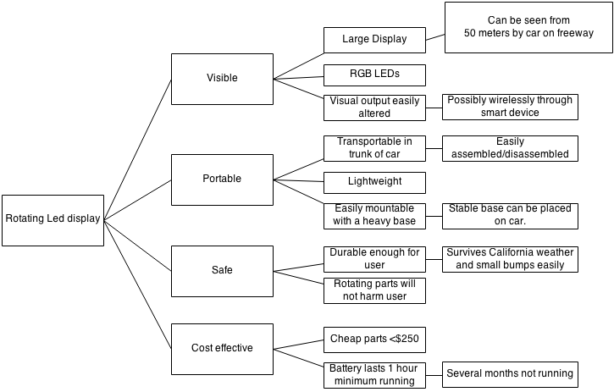

Chart 1.1 is basically showing that our project, the Rotating LED display will have to be visible, portable, safe, and cost effective. Each sub-category in the tree shows a little bit of what each category will require the group to do and is a more detailed expansion of the objective to the left of it.

* 1. **Pairwise Comparison Chart**

|  |  |  |  |  |  |
| --- | --- | --- | --- | --- | --- |
| Goals | Visible | Portable | Safe | Cost Effective | Score |
| Visible | … | 0 | 1 | 1 | 2 |
| Portable | 0 | … | 1 | 0 | 1 |
| Safe | -1 | 0 | … | 0 | -1 |
| Cost Effective | -1 | -1 | 0 | … | -2 |

Chart 1.2

Chart 1.2 shows the priorities of the project. It shows that our group is less worried about cost effectiveness and safety and more focused on how visible and portable it is. Each different category is compared with each other category, if our group is going to prioritize one category over the other, we put a 1 in that box. If they are equally important to our group, we put a 0 in that box, and if they are less important we put a -1. Therefore visibility is the most important part of the project, with portability slightly less important. Slightly less important than portability is safety, and behind that is cost. Cost is the least important because we would much rather it do what it is supposed to do than be cheap and inexpensive.

**1.6 Problem Definition**

Need:

Breaking down on the side of the road is a problem that daily commuters face. The original hazard lights on cars are just a way to warn other drivers that a car is stopped, but what if you need to communicate with others driving by or from a distance. Most drivers will drive by when they see a car with the hazards on and not stop to see if that person needs help. There needs to be a way to communicate a message to people driving by in case of an emergency. This same method that is used to get drivers attention and display a message could also be used as a form of advertisement by utilizing the device as a way to display ads and attract attention to the product or service being advertised.

Objective:

The objective of this project is to build a rotating LED wand that can be implemented to display pictures and words. This can be used to signal for help or advertise for a company. The device needs to operate on battery and can be disassembled and reassembled quickly and easily for transport.The battery life should last at least an hour when in use, and if not in use the battery should last for a few months. The project first and foremost needs to display visible words and images. Visibility at a reasonable distance is a very important factor. The device needs to be easily portable, safe, and cost effective. This design should be built affordably and should not harm the user.

Need:

When people first arrive at the engineering building, often they get confused and lost. This can make it difficult to arrive to classes on time and ready to learn. The building is naturally confusing with rooms and labels that don’t always make sense. This can be remedied through an app which makes maps and locations easily accessible to anyone.

Objective:

The objective of this project is to create an augmented reality app which can be implemented to help people find their way around the engineering building. This can be used through a menu to select where they are going and then directions can be shown on the screen using the augmented reality format. The app should provide easy to use directions which tell students how to get where they need to go.